3.1 Experiment No. : 03
3.2 Experiment Name : Application of HTML Table
3.3 Theory
This experiment demonstrates the implementation and application of HTML tables for structured data presentation. Tables organize information into rows and columns, creating a grid-based layout essential for displaying relational data like schedules, statistics, and comparative information. Modern web development reserves tables for tabular data (not page layouts), prioritizing semantic markup and accessibility.

Core Components
- Structural Elements
  - <table>: Container for all table elements.
  - <tr>: Defines a table row.
  - <td>: Standard data cell (contains content).
  - <th>: Header cell (bold/centered by default). Use scope="col" or scope="row" for accessibility.
- Semantic Sections
  - <thead>: Groups header content (e.g., column titles).
  - <tbody>: Contains primary data rows.
  - <tfoot>: For summary/footer rows (e.g., totals).
  - <caption>: Adds a descriptive title (above/below table).
- Advanced Attributes
  - colspan: Merges cells horizontally (e.g., <td colspan="2">).
  - rowspan: Merges cells vertically (e.g., <td rowspan="3">).
  - headers: Associates data cells with header IDs for screen readers.

Accessibility Essentials
- Always use <th> for headers with explicit scope attributes.
- Include <caption> or aria-label for context.
- For complex tables, pair headers in <td> with id in <th>:
html
- <th id="email">Email</th>
<td headers="email">user@example.com</td>

Best Practices
  - Use tables only for tabular data (not layouts).
  - Avoid nested tables; simplify structure.
  - Prefer CSS over deprecated attributes (e.g., border="1").
  - Validate accessibility with tools like WAVE or Lighthouse.

3.4 Problem Statement
The Bangladesh Army conducts weekly seminars covering topics like XML, XPath, XSL Transformations, and XLS Formatting Objects. Currently, there is no centralized web-based schedule for these sessions. The goal is to create a webpage that displays the seminar schedule in a clear, readable table, showing days, start and end times, and topics, while preserving the original table structure. The page should include a title, description, and footer note, use an open-source web font from a CDN, support dark mode, and remain responsive, providing army personnel with an accessible and professional online schedule.

3.5 Source Code
<!DOCTYPE html>
<html lang="en">
<head>
<meta charset="UTF-8" />
<meta name="viewport" content="width=device-width, initial-scale=1.0" />
<title>Seminar Schedule</title>

<!-- Open-source font from jsDelivr -->
<link
rel="stylesheet"
href="https://cdn.jsdelivr.net/npm/@fontsource/roboto@latest/index.css"
/>

<style>
body {
font-family: 'Roboto', Arial, sans-serif;
background-color: #f2f2f2;
display: flex;
justify-content: center;
padding: 40px 20px;
color: #000;
}

.container {
max-width: 900px;
text-align: center;
}

h1 {
color: #013220; /* Army green */
margin-bottom: 10px;
}

p.description {
font-size: 16px;
color: #333;
margin-bottom: 20px;
}

table {
border-collapse: collapse;
width: 100%;
}

td {
text-align: center;
}

tfoot p {
margin-top: 20px;
font-style: italic;
color: #555;
}

/* Dark mode support */
@media (prefers-color-scheme: dark) {
body {
background-color: #121212;
color: #e0e0e0;
}

h1 {
color: #a3d39c; /* light army green */
}

p.description {
color: #ccc;
}

table {
background-color: #1e1e1e;
border-color: #555;
}

table td,
table th {
color: #e0e0e0;
border-color: #555;
}

tfoot p {
color: #aaa;
}
}
</style>
</head>
<body>
<div class="container">
<h1>Bangladesh Army Seminar Schedule</h1>
<p class="description">
This table shows the weekly seminar schedule for army personnel.
Please follow the timings carefully.
</p>

<table border="1" align="center" cellpadding="10px">
<thead>
<tr>
<th rowspan="3">Day</th>
<th colspan="3">Seminar</th>
</tr>
<tr>
<th colspan="2">Schedule</th>
<th rowspan="2">Topic</th>
</tr>
<tr>
<th>Begin</th>
<th>End</th>
</tr>
</thead>

<tbody>
<tr>
<td rowspan="2">Monday</td>
<td rowspan="2">8:00 a.m</td>
<td rowspan="2">5:00 p.m</td>
<td>Introduction to XML</td>
</tr>
<tr>
<td>Validity: DTD and Relax NG</td>
</tr>
<tr>
<td rowspan="4">Tuesday</td>
<td>8:00 a.m</td>
<td>11:00 a.m</td>
<td rowspan="2">XPath</td>
</tr>
<tr>
<td rowspan="2">11:00 a.m</td>
<td rowspan="2">2:00 p.m</td>
</tr>
<tr>
<td rowspan="2">XSL transformation</td>
</tr>
<tr>
<td>2:00 p.m</td>
<td>5:00 p.m</td>
</tr>
<tr>
<td>Wednesday</td>
<td>8:00 a.m</td>
<td>12:00 p.m</td>
<td>XLS Formatting Objects</td>
</tr>
</tbody>
</table>

<tfoot>
<p>
Note: All timings are according to Bangladesh Standard Time
(BST).
</p>
</tfoot>
</div>
</body>
</html>

3.6 Output
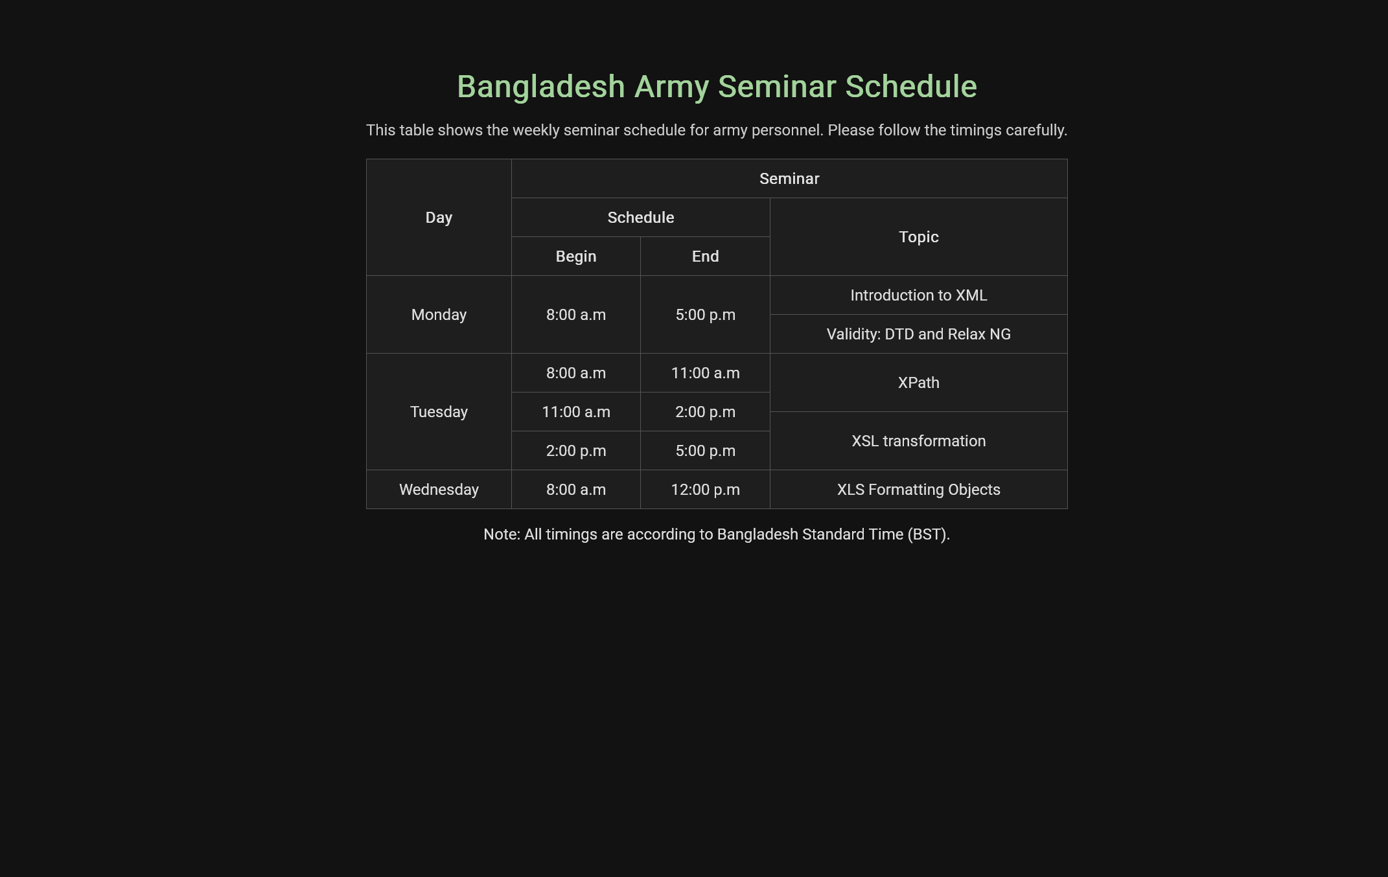

3.1: Dark mode of the Website

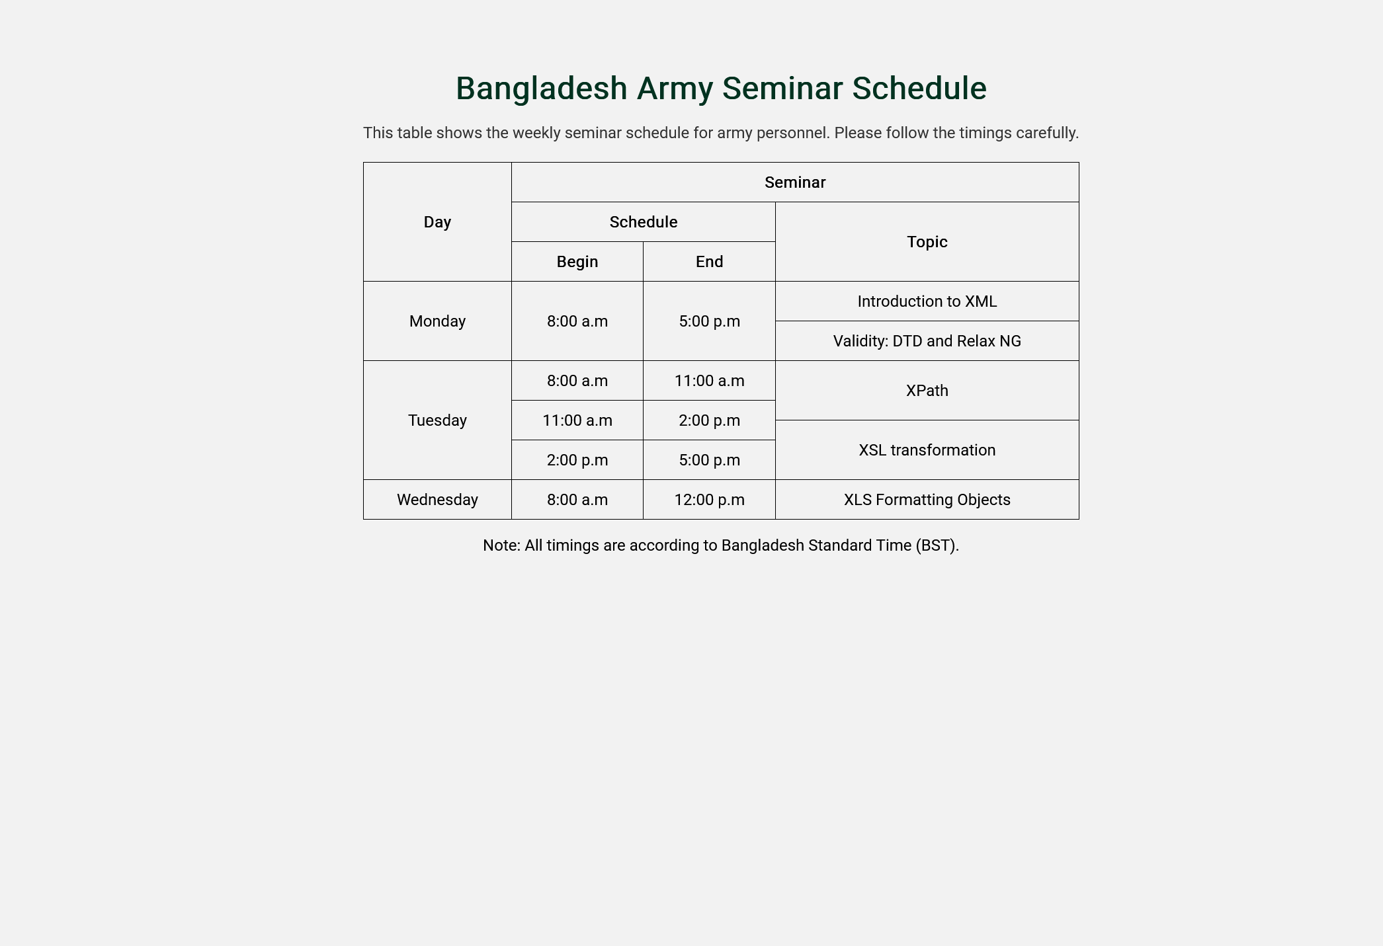
3.2: Light mode of the Website

3.7 Discussion
A web-based seminar schedule for the Bangladesh Army was created to demonstrate the importance of presenting structured information clearly and accessibly. The schedule was organized using a table, where days, timings, and topics were displayed to allow personnel to quickly understand their weekly agenda without confusion.
Rowspan and colspan were utilized to ensure that repeated information, such as day or time ranges, was consolidated, which reduced redundancy and improved readability. This design choice was made to keep the table concise while retaining all necessary details.
In addition to the table, contextual elements such as a title, description, and footer note were included to provide clarity and additional information, such as the timezone or purpose of the seminars. This ensured that the webpage was self-explanatory, even for new users.
Accessibility and usability were addressed by using a web font loaded from a CDN, so that the text was displayed cleanly and consistently across devices. Dark mode support was implemented to allow users to view the schedule comfortably in low-light conditions, enhancing readability and reducing eye strain. Furthermore, the webpage was designed to be responsive, making it accessible on desktops, tablets, and mobile devices.
The original table structure was preserved, ensuring that the integrity of the data was maintained while keeping the implementation straightforward. No additional styling was applied to the table itself, and surrounding texts were styled subtly to provide context without overwhelming the table.
Overall, clarity, usability, and visual appeal were balanced, and a professional and accessible online schedule was provided that met the needs of Bangladesh Army personnel efficiently.

